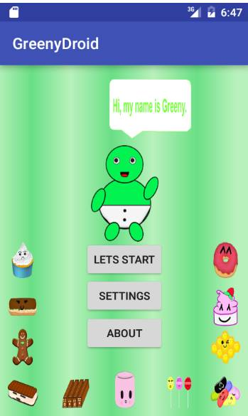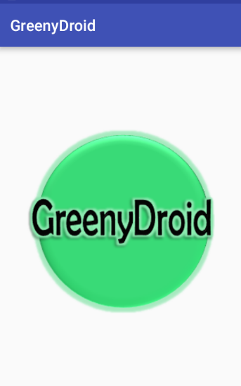

MAIN PAGE  
 This is the main page of the application. There are three buttons: LET’S START, SETTING, and ABOUT.

WELCOME SCREEN  
 This is the welcome screen of the application. While loading, the GreenyDroid logo will turn around.

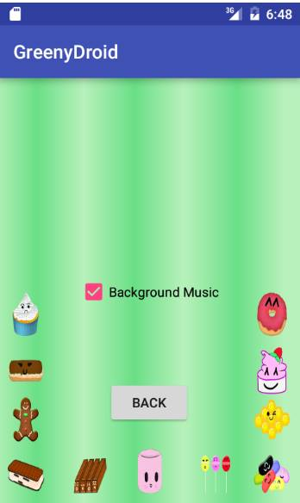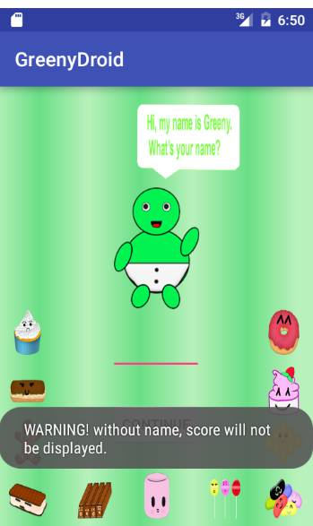

SETTING SCREEN  
 When the user clicks the ‘Setting’ button, it will display a screen where the user may turn on or off the background music

GET NAME SCREEN  
 When the user clicks the ‘Let’s start’ button, it will display a screen where the user should put his/her name.

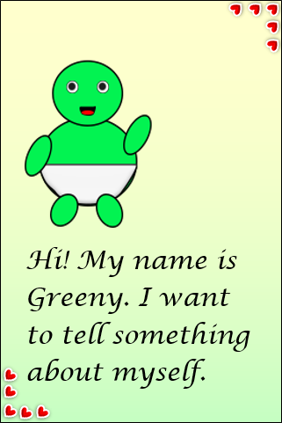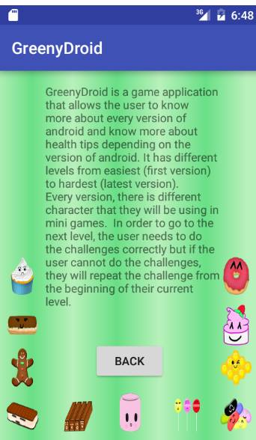

BEGIN

INTRODUCTION SCREEN  
 After the user enters his/her name, there are introduction / instruction before the story.

ABOUT SCREEN  
 When the user clicks the ‘Let’s start’ button, it will display a screen where the user should put his/her name.